Executive Summary
Purpose and key insights:
We had three main goals when beginning this engagement. The first was to find any inefficiencies with the bagel production process that were leading to wasted bagels. What we found was that the highest bagel that was wasted was actually one of the most efficient bagels by waste percentage. For example, the plain bagel sold the most so therefore it had the most bagels wasted, but when you looked at the plain bagel’s efficiency it had one of the lowest waste rates by percentage. We also analyzed bagel waste by employee and found that employees who worked more wasted more, which was our assumption. We did find employees that wasted bagels at a higher rate than others, no matter the amount baked. The second was to analyze weather patterns and how they affected sales. By looking at weather trends, we can see how to reduce, not just bagel waste, but all waste with all food items. Specifically, the goal is to see how precipitation and temperature affect sale of items. Finally, we looked at the actual hours each employee was working vs their scheduled hours. Many employees were starting early and leaving late. While this may be a sign of high traffic forcing employees to arrive earlier and stay longer, it is also increasing salaries and wages expenses for every extra hour worked. We wanted to bring this to light to make sure the hours worked are what is expected.
Forward-looking insights:
We could anticipate going forward that if you do not cut down baking pumpernickel bagels, then their waste rate will continue to rise throughout the year because people are not buying pumpernickel bagels. Based on historical data, we anticipate that the bakers Marino Cardello and Andre will continue to waste bagels at a higher rate. There will also be null bakers that continue to be entered if bagels are not assigned to bakers. We also anticipate large amounts of hours worked over what is scheduled and budgeted for.
Recommendations:
- Ensure that employees are adequately trained to only bake needed quantity and variety of bagels, for example, do not bake a large quantity of pumpernickel bagels because they have the highest waste rate.
- Look at weekly forecasts and reduce all food waste by ordering more direct for the season, such as more smoothie items in warmer weeks, more lunch items on rainier weeks, and more burritos in the winter.
- Scheduled shift hours may need to be followed more strictly or incorporate a more accurate scheduling strategy when budgeting for hourly employees.
Any assumptions or limitations:
One thing to keep in mind when looking at the overtime hours worked is “Late Starts” and “Early Ends” were not included in the “Overtime Minutes” visual. This would have decreased the total overtime hours worked for each employee. They were not included because they were less common and typically consisted of less time. They combined for 1,830 hours and 36 minutes whereas “Early Starts” and “Late Ends” combined for 4,074 hours and 14 minutes over the time period 7/1/2023 through 9/1/2025. Unscheduled shifts were taken out, but consisted of 1,965 hours and 31 minutes of OT.

Appendix
- Cleaning “bakewaste2425” data
Description: We needed to clean this dataset to do a proper analysis. To do this we used two power queries in excel. The first melted the baked columns so that each variety had its own row (making 21 rows per date) and had a column next to that with the count of that variety on that date. The second did the same thing with the wasted columns. To do this, we highlighted the data, went to the data tab, and used the “get data from table and range” tool. We then highlighted the columns, went to the transform tab, and used the “unpivot columns” tool. We combined the variety columns into one and put the “Baked” and “Wasted” columns next to each other. We calculated the difference to find the “Sold” amounts. Lastly, we formatted dates and baker names to be uniform throughout.
Screenshots:
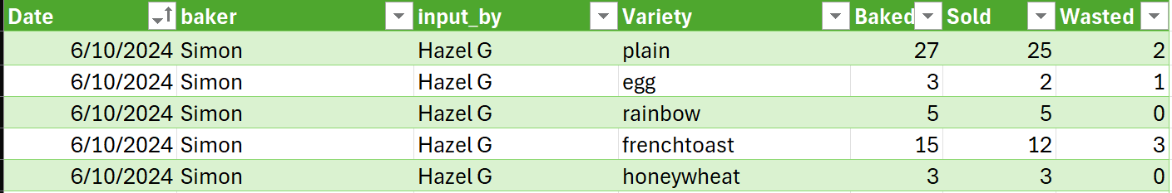

- Waste Rate Efficiency
Description: We used the bakewaste2425 dataset, which shows how many bagels of each variety were baked and how many ended up being wasted each day. To compare flavors more fairly, we created a calculated field called Waste Percentage using the formula SUM([Wasted]) / SUM([Baked]). I used the SUM version so Tableau would calculate the percentages at the variety level, instead of row by row. The main reason we created this field is because total waste by itself can be misleading; some bagels look wasteful just because they’re baked in large quantities. Waste Percentage helped me see which flavors were actually being overproduced. I used this field in my scatter plot (waste % vs. total waste) and paired that with a bar chart showing total waste by variety so we could look at both the volume of waste and the efficiency of each bagel flavor.
Screenshots:
Clean data
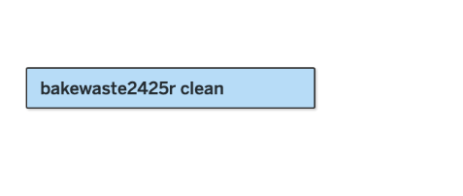
Calculated Field
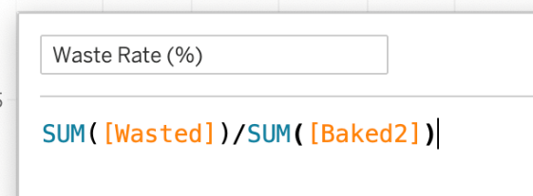

- Bakewaste by baker
Description: We used the bakedwaste2425 dataset which we cleaned. We wanted to see bagels that were wasted broken down by each employee. It was not an option to look at which employees wasted the most bagels because the employees that bake the most would have more wasted naturally. To find this data in a non-skewed manner, we divided the amount of wasted bagels per employee by the total amount they baked, which gives us a percentage of wasted bagels per employee. This was completed by creating a calculated field in Tableau. In this field the Wasted bagels were summed and then divided by the sum of baked bagels. This is displayed in a bar chart with the Bakers on the y-axis and the waste rate percentage on the x-axis. The bakers are listed in descending order from most waste to least.
Screenshots:
Cleaned Data
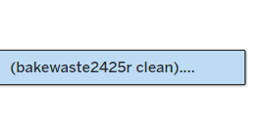
Calculated Field
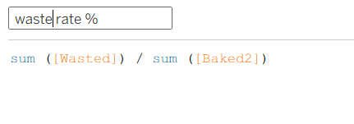
- Sourcing historical weather data.
Description: Used Open-Meteo, a well-known reliable weather API that pulls data from official sources such as the NOAA. First, we found the location of the Longitude and Latitude of the city of Lewisburg, PA. Then, entering that, we filtered the dates to match the dates on the clover dataset. Lastly, select the precipitation sums and mean temperature for each day in that time frame.

- Timesheet and Payrate data transformation
Description: In Excel, we found the difference between the scheduled start times and actual start times. We also did this for the actual end times and scheduled end times. This was done by subtracting one from the other. These columns were named “Early Start” and “Late End”. The Timesheet and Payrate data were then imported into Tableau. We joined the two on the “Emp ID” and “ID” columns and made these the columns. For the rows, we created a calculated field. First, we calculated the total number of minutes for each “Early Start” and “Late End”. We then added these numbers together to get a total number of overtime hours worked. This was placed in the rows to calculate the overtime hours per employee. Lastly, we labeled each bar so a quick calculation could be made between extra hours worked and hourly rate. Filters were added for the date, employee ID, role, and AGG(total overtime hours).
Screenshots:
Early start minutes Late end minutes
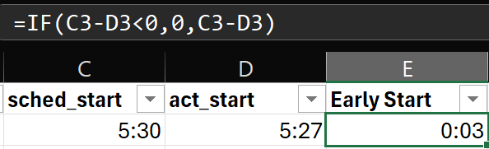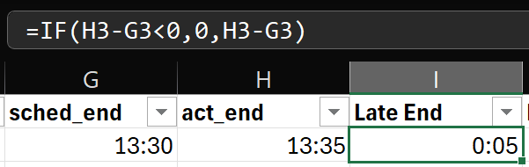
Importing into Tableau and joining the datasets
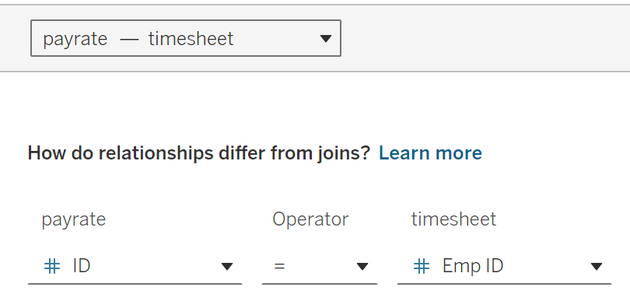

Calculated fields
